

*Perfect high school in Battambang province.*

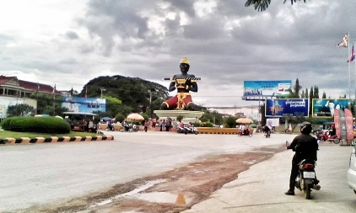Battambang province is very famous in Cambodia. Everybody always heard about an awesome thing from this beautiful province. The first thing that make everyone can defined Battambang is Ta Dombang KroNhoung statues. Exactly Battambang is the best place for growing some things especially fruits like orange that popular in there. Another thing is resort. In Battambang have a lot of natural resorts for relaxing and visiting. it makes a lot of national and international tourists per years. Moreover, many people in Battambang are full of talents of course many of artist in Cambodia are from Battambang especially singer. They believe that the people are from Battambang have very sweet voice like Ruoserey Southa she is top of classical singer in sixth decade of Cambodia. But not only this part that make Battambang famous it also has a good quality of education.it have a lot of school everywhere every section and every level. High school is last stages of student for study before they came to university. Battambang province has a lot of famous high school in Cambodia also. But the biggest and have good location in Battambang is Net Yong high school.

*Net Yang high school*

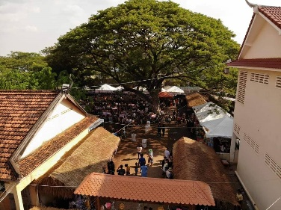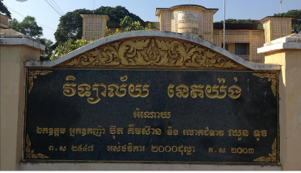 Net yang high school is the biggest high school in Battambang province.it situated along the road number five and behind Ta Dom bang kroNhoung statues. It was builds in 1953. This high school have a lot of class room for studying and a lot of best teacher to teaching. However, the student and teacher always have good relationship with each other. The student always followed the rule of school and have good attitude with each other. And this school is very big. It makes student comfortable for study. And it has some many shop that sell all of study materials for study. Moreover, it also has food shop that have breakfast and lunch for student to eat on time. Because this school we study in morning from 7:oo until 11:00 afternoon from 1:00 pm untial 4:00 pm.

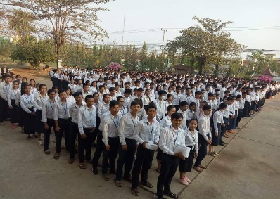

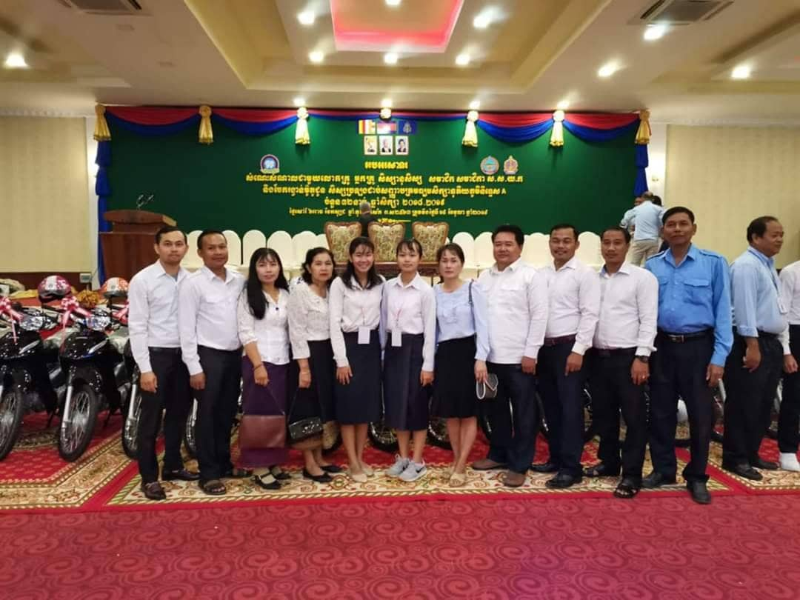Every student in there are very smart, clever and study hard. They always help each other. In fact, In2019 there are 2 students in Net Yang high school that got top 5 of clever student of Battambang province and 2 student got grade A in national exam also. More than this net Yang school always enjoy every sport competition and got a lot of campion of provinces.

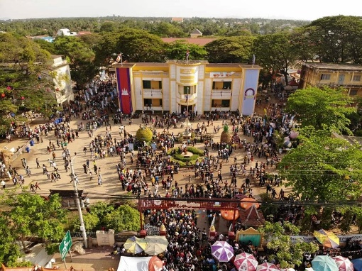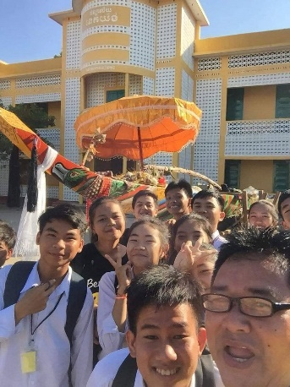However, every national event they always celebrate in there such as Khmer new year. They celebrate in this school because it has very big place to something. Especially they always celebrate Sorng Kran new year on Khmer new year every year in net yang high school. They are a lot of people come to join this event because it has a lot of Khmer shop for sell something and relaxing place that play many Khmer popular games. That why it makes everyone know this school clearly. Moreover, Net yang high school is

